Samwel, Youssef

Portfolio 2

# Add.asm

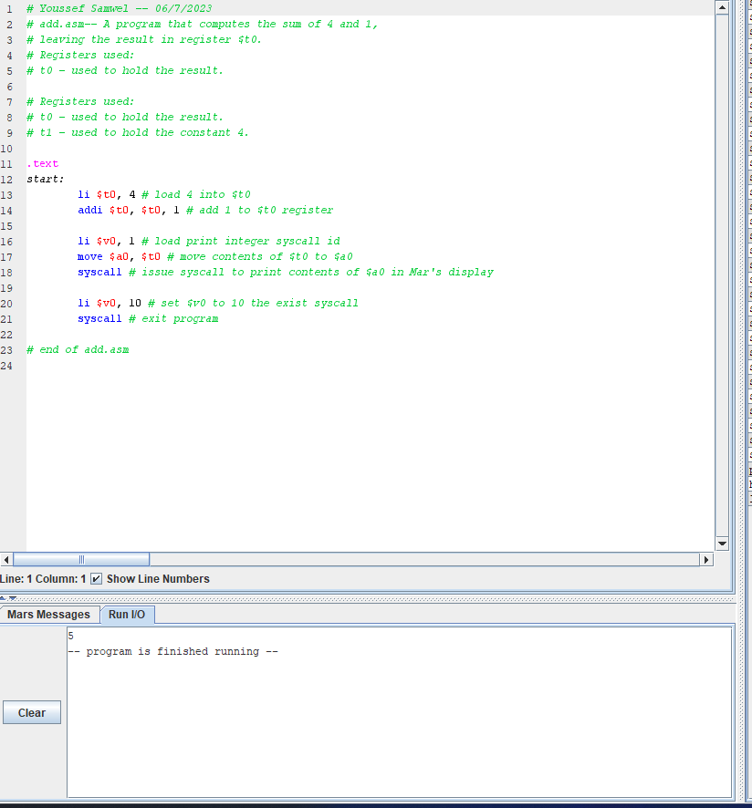

# Exercise 1

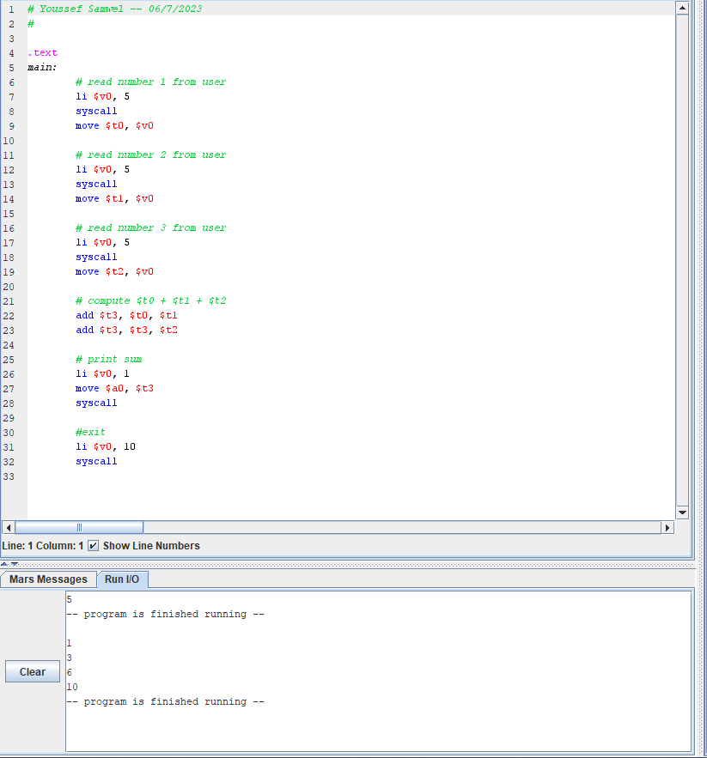

# Exercise 2 (Decimal)

# Exercise 2 (Hexadecimal)

